**CHAMBER FURNACES AND QUENCHING BATH**

**The equipment will be used for:** *choose one answer only

Pre-heating

Tempering, annealing

Quenching

Laboratory

Jewellery

Ceramic firing

Decorating

Glass

Rubberizing

Plastics

**Description of the technology[1]**

**Material to be treated**

Material type**[2]**

Weight and dimensions of each piece

|  |  |  |  |  |  |
| --- | --- | --- | --- | --- | --- |
|  | Width (mm) | Height (mm) | Depth  (mm) | Diameter (mm) | Weight  (kg) |
| min |  |  |  |  |  |
| max |  |  |  |  |  |

Total weight of charge (all pieces in the furnace) kg

Water content in the charge:  No Yes Amount kg

Release of gas in the charge  No  Yes Type

Flammable or explosive content in the charge:  No Yes

Occurrence of thermoreaction:  No Yes

**Heat process profile[3]**

Submit the heat curve of the heat treatment process, maximum desired temperature and operating temperature (describe in your own words or attach your own picture graph):

Heat distribution requirements: +/- °C

Requirement to meet AMS 2750 standards:  No  Yes Furnace category

Instrumentation type

**Furnace type** *choose one answer only

Front loading

Bogie hearth

Shaft

Top loading

Bottom loading

Other type

**Door opening:** *choose one answer only

Left

Manual Right

Upwards

Downwards

Left Automatic  Right  
Upwards  
 Downwards  
  
 Hydraulic  
Electric  
 Pneumatic

**Required inner dimensions of the furnace:**

Width (mm)

Height (mm)

Depth (mm)

Diameter (mm)

Charge loading height requirement (mm)

**Inner furnace accessories**

Shelves:  No Yes Number   
 Max. load capacity kg

Charge basket:  No Yes Number   
 Max. load capacity kg  
 Height mm  
 Width mm  
 Depth mm  
 Diameter mm

Other accessories:

**Batch handling method** *choose one answer only

Manual

Forklift

Crane

Other

**Heating** *choose one answer only

Max. installed power kW

ElectricPower supply[4]

Connection to energy peak monitor:  No  Yes

Natural gas Gas  Propane  
LPG  
 ELTO[5]  
  Other   
 Direct heating  
Indirect heating  
   
 Recuperation:  No  Yes

**Temperature regulation** *choose one answer only

Regulation at constant temperature[6]

Regulation using freely programmable curves[7]

Multi-zone regulation:  No  Yes Number of zones

Charge thermocouple:  No  Yes  Regulation according to the batch thermocouple

Only show the batch thermocouple

Regulator type:  Use the standard type provided Other

**Temperature recording**

Temperature recorder:  No Yes  Digital

On paper

Communication interface[8]:  No  Yes RS232, EIA-485  
LAN

Equipment for monitoring and recording the temperature cycle[9]:  No Yes

Other recording:

**Cooling of the charge**

No Yes **\***choose one answer only

Unregulated cooling[10]   
 Fill in cooling rate requirements[11]

Regulated cooling[12]   
 Fill in cooling rate requirements[13]

**Quenching bath requirement**

No Yes  Water

Quenching media type  Polymer  
  Oil

Charge temperature before quenching °C

Max. temperature of quenching media °C

Min. temperature of quenching media °C

Max. charge weight kg

Maximum quenching cycle frequency  
 for most common charge

Method of charge handling  
 on load grid

Quenching media cooling:  No  Yes

**Supply of protective atmosphere**

No Yes

Type of protective gas

Protective  Bottled  
 gas supply   
 type  Factory connection  Factory gas connection pressure

Gas supply  Automatic  
 regulation   
 method  Manual

Desired effect of protective

gas on charge

Operating container for heat treatment with protective atmosphere:  No  Yes

**Furnace ventilation** *choose one answer only

Manually controlled ventilation flap

Automatically controlled flap

No ventilation

Suction ventilator

Will the equipment be connected to air-conditioning equipment:  No  
  Yes m3/hour

**Installation requirements**

Smallest dimensions through which the equipment must be transported (doors, lift, system of cables, etc.)

Width (mm)

Height (mm)

Installation footprint (desired external dimensions)

Width (mm)

Height (mm)

Depth (mm)

**Required surface temperature standard** *multiple choice

No Yes

CSN 33 2000-4-42

IEC 364-4-42

DIN VDE 0100-420

**Documentation requirements**

Language required on production labels:

Language required for documentation:

Other documentation requirements:

**Contact information**

Name:

Surname:

Company:

E-mail:

Phone :

Additional notes or inquiries on furnace parameters:

**GLOSSARY OF TERMS**

1. Specify the technology for which the equipment will be used. Eg.: Tempering - heating parts made of tooling steel and hardening in oil bath. Annealing - Annealing welded parts to relieve stress.
2. E.g.: tooling steel 1.2510.
3. See image bellow.

   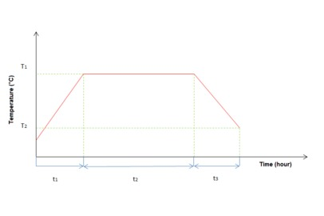
4. If different from 3/N/PE 400/230V AC 50Hz).
5. Light heating oil - oil with viscosity of max. 6 mm2/s at 20 °C (e.g., motor diesel) - it is necessary to specify the parameters for assessment of suitability. Higher viscosity heating oil may be used with adjustment of the burner (necessary to supplement with preheating of fuel).
6. See image bellow.

   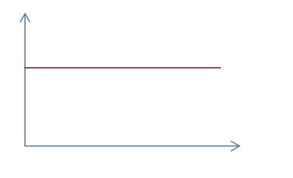
7. See image bellow

   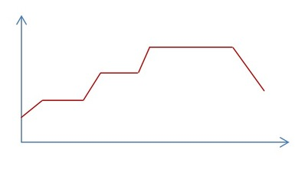
8. Interface RS232, EIA-485 or LAN. Includes a connector situated on an accessible place on the furnace.
9. HtMonit EV set – includes the interface, cable between the furnace and the PC and software. Connector interface (RS232, EIA-485 or LAN) is situated on an accessible place on the furnace. Software equipment – HtMonit EV program is designed for monitoring and archiving measured values ​​up to 4 devices fitted with controller or measurer Ht series (Ht200/Ht205, Ht Industry, Ht40AL, Ht40A, Ht40P, Ht40B, Ht40T, Ht60B, Ht60M a Ht100).
10. The furnace will be ventilated actively (ventilation fan) or passively (chimney effect), thus cooling the charge. The size of the charge has an effect of the cooling rate.
11. Example: Cool a 100 kg charge at 650 °C to 100 °C within maximum period of 2 hours.
12. The furnace will regulate the temperature in the chamber (if a charge thermocouple is used, the temperature will be regulated according to the temperature of the charge) in such a way that the required cooling speed will be maintained. The selected temperature is maintained through the adjustment of the furnace flaps and may also be through the heating elements in the furnace.
13. Example: Cool a 100 kg charge at 650 °C to 400 °C within 1 hour. The description of cooling should focus on the temperature range specifically required by the chosen heat treatment process. In particular, requirements for heating at low temperatures may lead to unnecessary cooling capacity.